Date: 06.06.2025
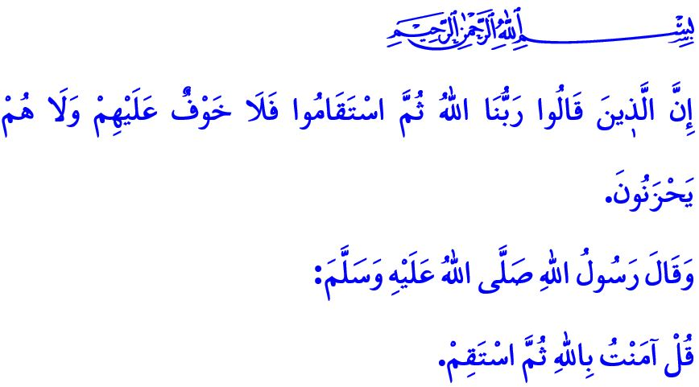
MUSLIMS HAVE A STANCE
Honorable Muslims!
On one occasion, one of the noble Companions said to the Prophet Muhammad (saw), “Tell me something about Islam that will make it unnecessary for me to ask anyone else.” Upon this, the Messenger of Allah (saw) said: قُلْ آمَنْتُ بِاللّٰهِ ثُمَّ اسْتَقِمْ “Say ‘I affirm my faith in Allah’ and then remain steadfast to it.”
With these concise and profound words, the Prophet Muhammad (saw) teaches us that Muslims possess unwavering faith and a firm, upright stance upon the path of righteousness.
Dear Believers!
Muslims have a stance. This stance is one of faith: one that loves Allah and His Messenger more than anyone and anything else, and takes the Qur’an and the Sunnah as its guide. In accordance with the verse, وَهُوَ مَعَكُمْ اَيْنَ مَا كُنْتُمْۜ “And He is with you wherever you are,” Muslims act with the awareness that they are always under the watch of their Lord. Just like the pilgrims at ‘Arafat, who perform waqfah stripped of all rank and status, clad in their ihram like a shroud, Muslims turn their faces toward the Baytullah and their hearts toward Allah.
Dear Brothers and Sisters!
Muslims have a stance. This stance is the consciousness of servitude that keeps our faith alive, refines our character, and grants us a distinct identity. Muslims, regardless of conditions or circumstances, must not sacrifice their acts of worship for the temporary life of this world. Worship should not be neglected due to reasons such as work and business life, school, or vacation. Indeed, the Prophet Muhammad (saw) informs us in a sacred hadith conveyed from Allah the Almighty that the most beloved actions which draw servants closer to Allah and earn His love are first the obligatory acts of worship, followed by the supererogatory ones.
Dear Believers!
Muslims have a stance. This stance is one that takes the character of the Prophet Muhammad (saw) as its standard in every aspect of life—from family and neighborly relations, to business and trade, from school to traffic, and in all other areas of daily living. Muslims, in accordance with the verse of Allah the Almighty, “˹They are˺ those who donate in prosperity and adversity, control their anger, and pardon others...”, must uphold love in place of violence, mercy instead of anger, and goodness in place of evil in their daily lives. They must regard all haram acts, such as interest, alcohol, gambling, adultery, slander, and lying, as pieces of the fire of Hell. They should root out from their lives harmful traits like laziness, indifference, begging, and earning without effort. They must never reach for anything to which they have no rightful claim.
Dear Believers!
Muslims have a stance. This stance is a moral and conscientious one that stands against oppression and oppressors, and supports the oppressed and the wronged. In accordance with the verse, “O believers! What is the matter with you that when you are asked to march forth in the cause of Allah, you cling firmly to ˹your˺ land? Do you prefer the life of this world over the Hereafter?” Muslims must not abandon the children of the ummah in Palestine and Gaza to the mercy of Zionist oppressors and their collaborators. While the oppressed are suffering from hunger and devastation, Muslims must not live as if nothing has happened or as if everything were normal.
Dear Muslims!
Today, as believers, we are in need of a stance that is truly Islamic—a way of life commanded by Allah and His Messenger. As our beloved Prophet (saw) said in the hadith, اَلْمُؤْمِنُ لِلْمُؤْمِنِ كَالْبُنْيَانِ يَشُدُّ بَعْضُهُ بَعْضًا “The believers are like bricks of a building, each part supporting the other,” we are in need of a stance that binds us together, one marked by compassion and mercy in our dealings with one another. We are in need of a stance that is honorable, steadfast, and principled—one that does not bend or break in the face of worldly interests. We are in need of a stance that carries burdens rather than becoming a burden; that is marked not by laziness, but by diligence and productivity; that acts not with hatred and resentment, but with love and respect. In short, we are in need of a stance that reflects our faith in our worship, our worship in our character, and our character in every aspect of our lives.

I conclude this week’s khutbah with the glad tidings from the following verse of our Exalted Lord: “Surely those who say, ‘Our Lord is Allah,’ and then remain steadfast—there will be no fear for them, nor will they grieve.”

Muslim, Iman, 62; Ibn Hanbal, III, 413.
Hadid, 57/4.
Abu Dawud, Tatawwu’, 27.
Ali ‘Imran, 3/134.
Tawbah, 9/38.
Bukhari, Mazalim, 5.
Ahqaf, 46/13. General Directorate of Religious Services

